**Data Testing Assessment**

A school 'Study & Play' has different branches in India. Students appeared in 10th & 12th board have scored good marks in different subjects. 'Study & Play' wants to recognize teachers across different streams to award them for their student's performance.

'Student & Play' are looking for a data warehouse solution to do analysis on student performance in a particular branch or subject.

**Exercise -**

As a part of this exercise, use the below Student data to import in database table.

Sample Data –

|  |  |  |  |  |
| --- | --- | --- | --- | --- |
| Student Name | StudentRollNo | Class | Age | Father's Name |
| AJAY KUMAR | IETLINF01 | X | 16 | PREM KUMAR |
| RAJAT MISHRA | IETLINF02 | XI | 17 | PANKAJ MISHRA |
| SUDHEER SHARMA | IETLINF03 | IX | 15 | SUNDER SHARMA |
| NANCY KAUR | IETLINF04 | XII | 18 | AK SINGH |
| SUMITA SHARMA | IETLINF05 | IV | 14 | AJAY SHARMA |
| NANDINI GUPTA | IETLINF06 | VII | 18 | RAM GUPTA |
| RAM KUMAR | IETLINF07 | X | 16 | RAMAN KUMAR |

Tasks

1. Create above table in database and insert the data.
2. Write sql query to find out total number of students in each class.
3. Write sql query to find out average age of students in each class.
4. Write sql query to find out the number of students having same roll no.
5. Write sql query to view the duplicate name of a student from the table.

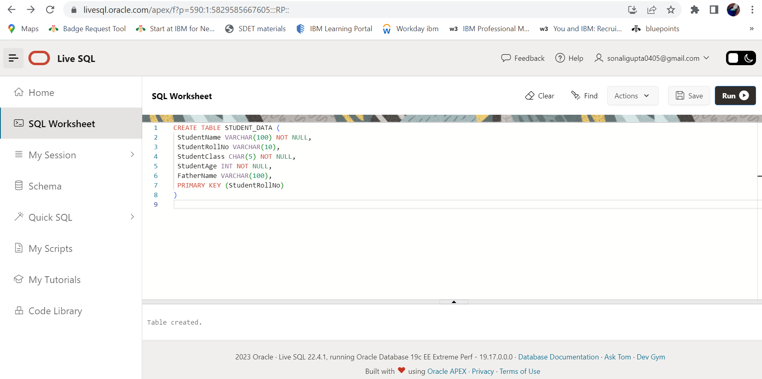

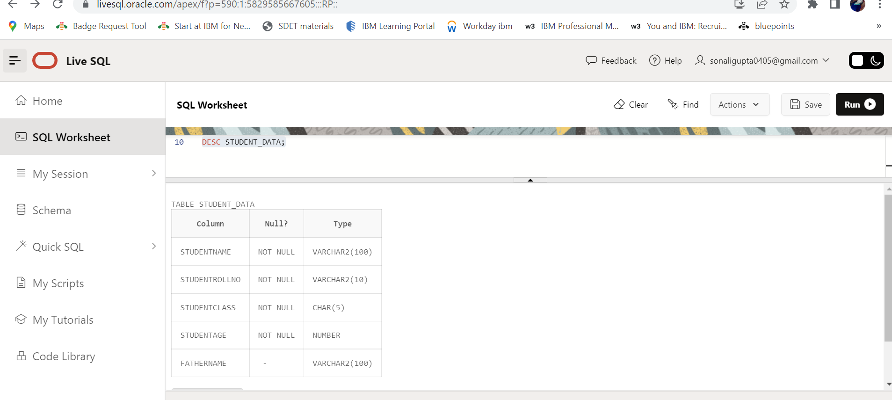

**INSERTING THE GIVEN DATA**

INSERT INTO STUDENT_DATA VALUES ('AJAY KUMAR','IETLINF01','X',16,'PREM KUMAR');

INSERT INTO STUDENT_DATA VALUES ('RAJAT MISHRA','IETLINF02','XI',17,'PANKAJ MISHRA'); INSERT INTO STUDENT_DATA VALUES ('SUDHEER SHARMA','IETLINF03','IX',15,'SUNDER SHARMA'); INSERT INTO STUDENT_DATA VALUES ('NANCY KAUR','IETLINF04','XII',18,'AK SINGH');

INSERT INTO STUDENT_DATA VALUES ('SUMITA SHARMA','IETLINF05','IV',14,'AJAY SHARMA'); INSERT INTO STUDENT_DATA VALUES ('NANDINI GUPTA','IETLINF06','VII',18,'RAM GUPTA');

INSERT INTO STUDENT_DATA VALUES ('RAM KUMAR','IETLINF07','X',16,'RAMAN KUMAR');

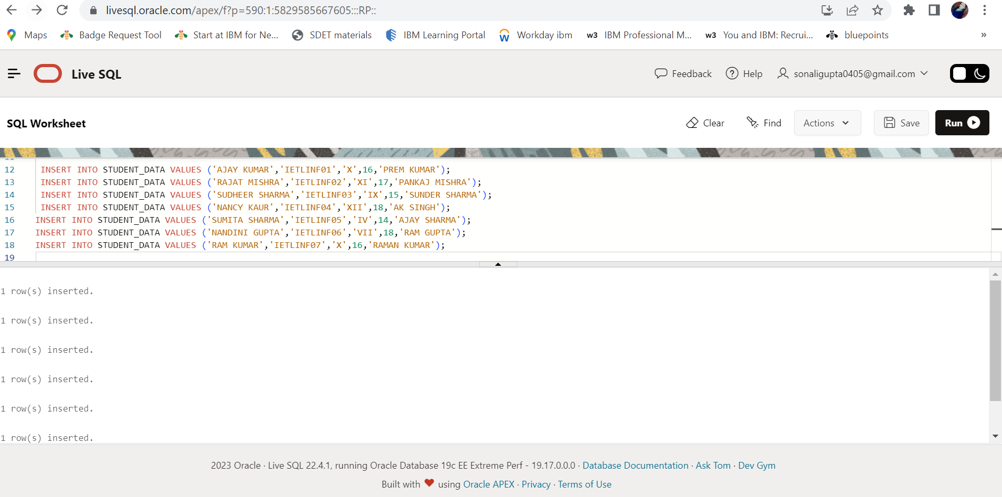

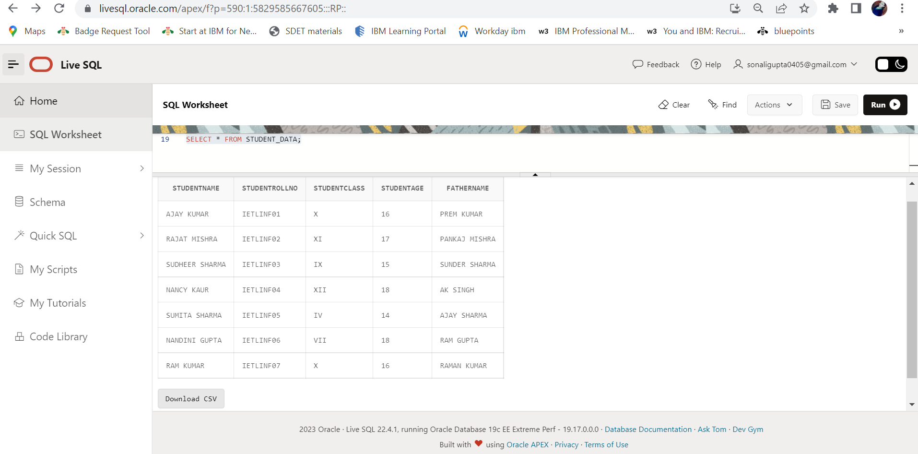

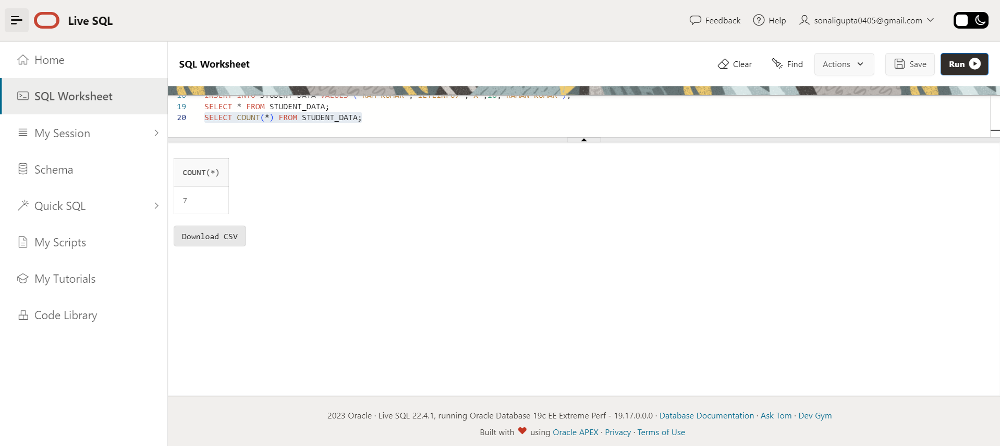

**2 ND) Write sql query to find out total number of students in each class.**

SELECT STUDENTCLASS, COUNT(STUDENTROLLNO) AS TOTAL_STUDENT FROM STUDENT_DATA GROUP BY STUDENTCLASS;

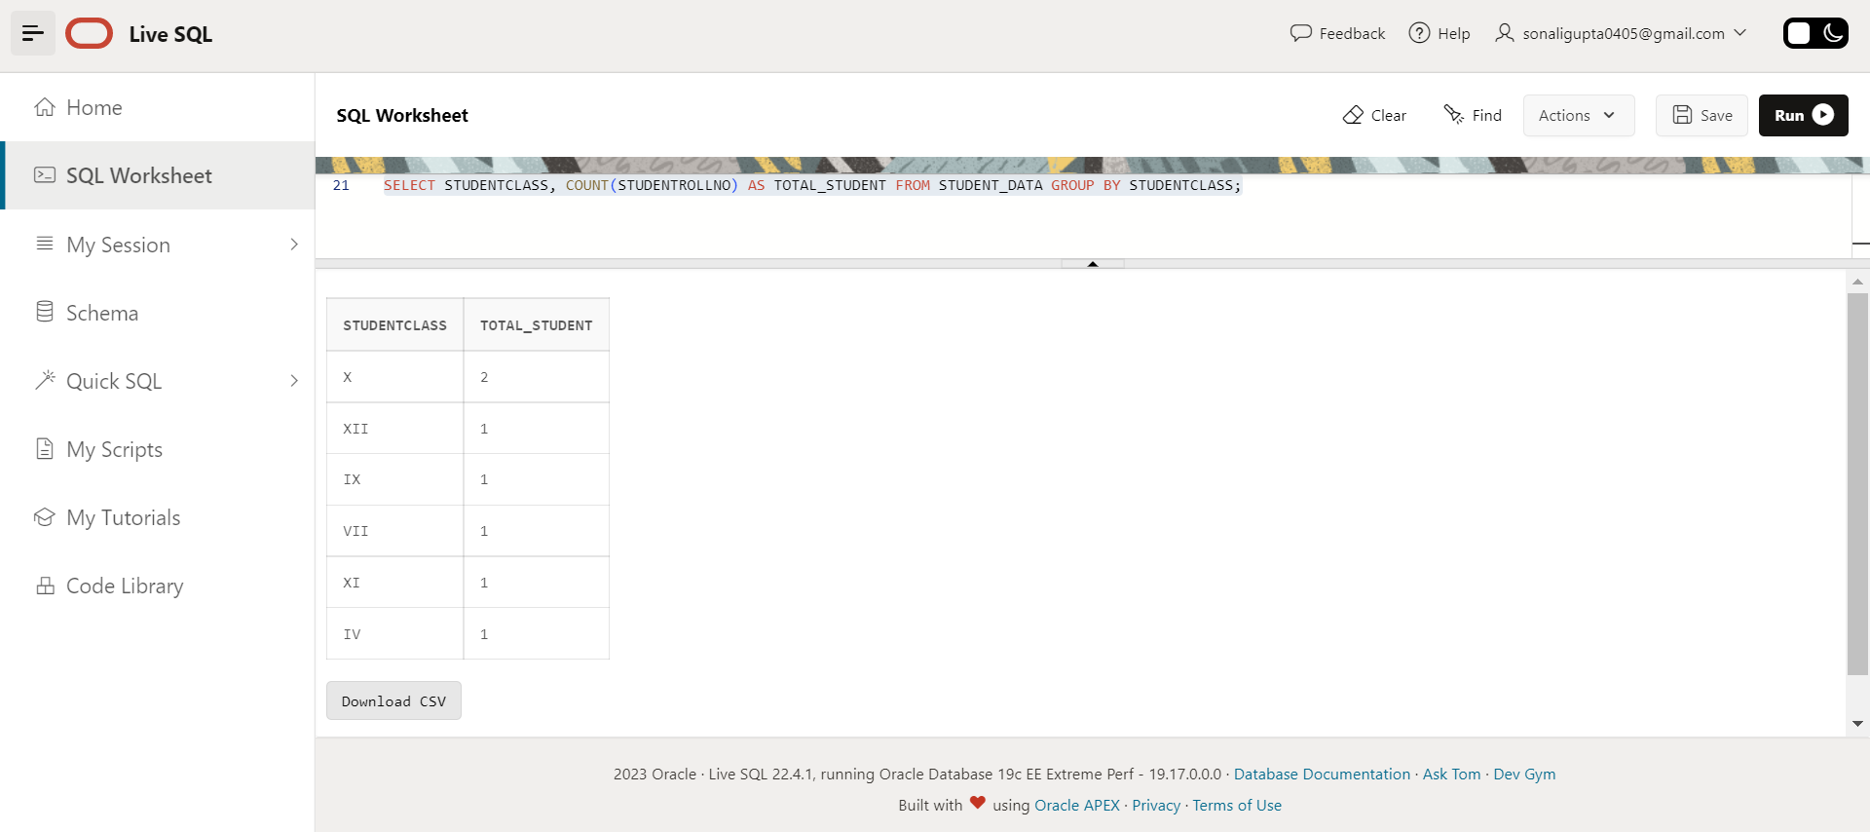

**3 RD) Write sql query to find out average age of students in each class.**

SELECT STUDENTCLASS,AVG(STUDENTAGE) AS AVG_AGE_OF_STUDENTS FROM STUDENT_DATA GROUP BY STUDENTCLASS ORDER BY STUDENTCLASS;

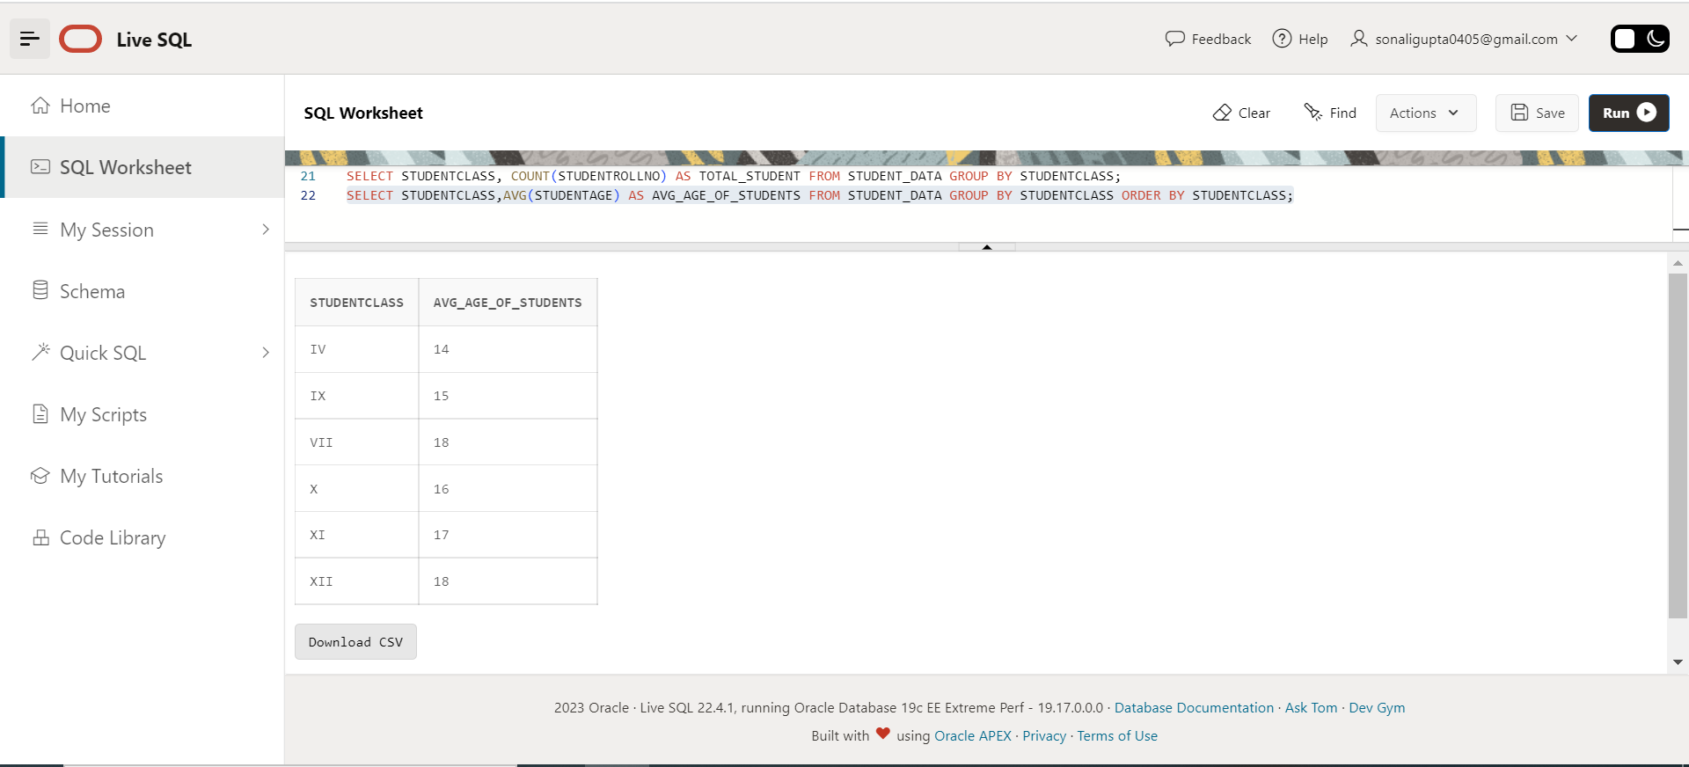

**4 TH) Write sql query to find out the number of students having same roll no.**

SELECT STUDENTROLLNO, COUNT (DISTINCT STUDENTROLLNO) AS SAME_STUDENT_ROLLNO FROM STUDENT_DATA GROUP BY STUDENTROLLNO;

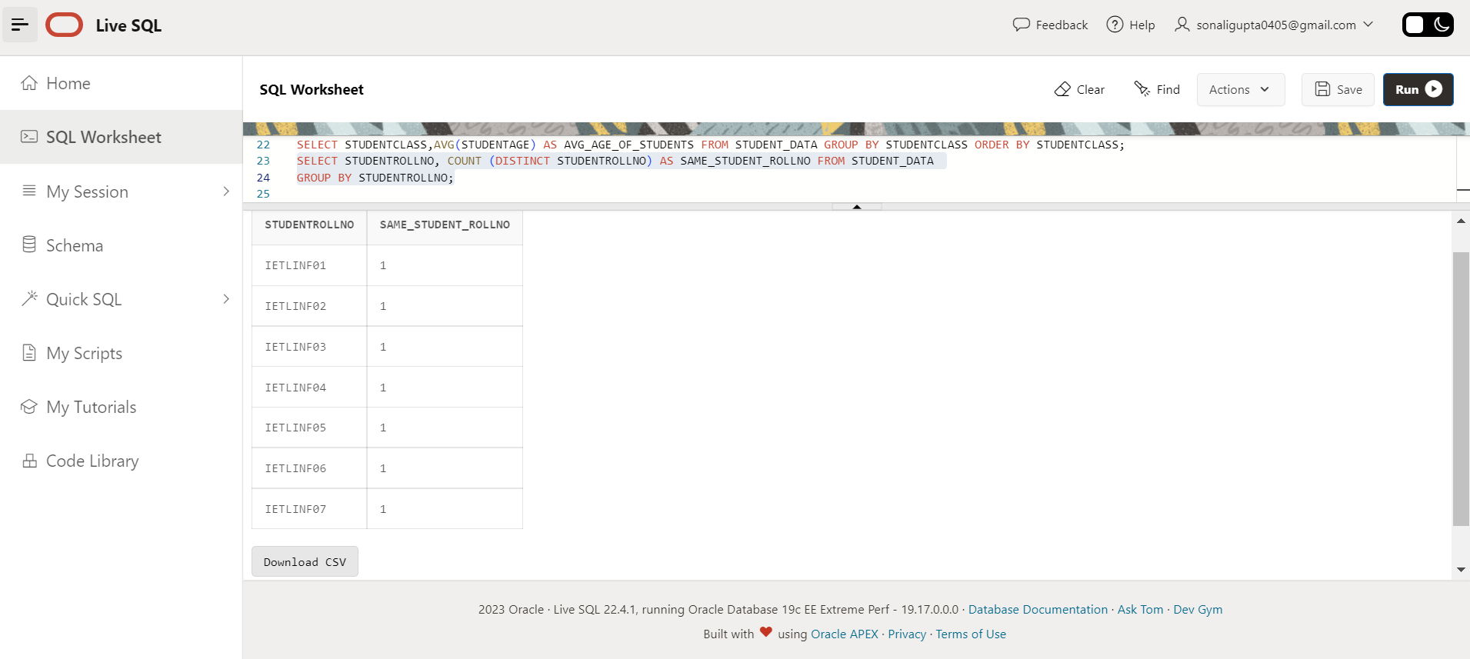

THERE ARE NO SAME ROLL NO STUDENTS.SO,IN RESULT IS NO DATA FOUND.

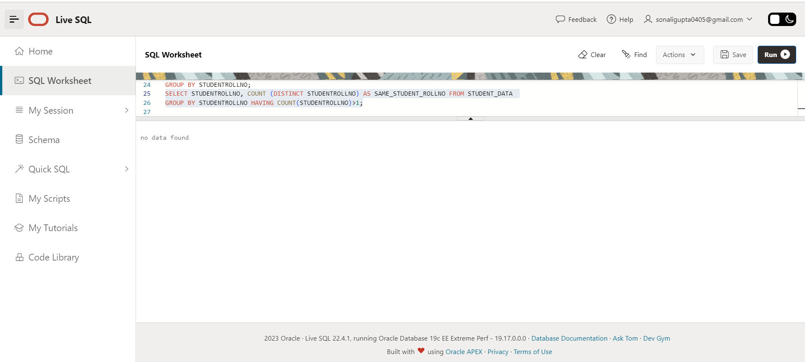

**5 TH) Write sql query to view the duplicate name of a student from the table.**

SELECT STUDENTNAME, COUNT (*) AS STUDENT_NAME_OCCURANCE FROM STUDENT_DATA GROUP BY STUDENTNAME HAVING COUNT(STUDENTNAME)>1;

THERE ARE NO NAMES SIMILAR.SO,IN RESULT IS NO DATA FOUND.

